FORM TO FILL UP TO SPONSOR A CHILD FROM RUIGO ACADEMY
(With Mac click on the square with the space bar, in Windows with the mouse)

About You
Female ☐ | Male ☐
Name: |  | Surname:
Passport Nº: |  | ☐ Less than 18 years ☐ over 18 years ☐ over 40 years

Mailing Address
Street: |  | City
Country: |  | Zip Code:
Cell phone: | Email:

Annual School fee paid in January (includes tuition, school material, uniform and health insurance)
50 €

Payment Method (choose an option)
☐ Pay through PayPal - click here | 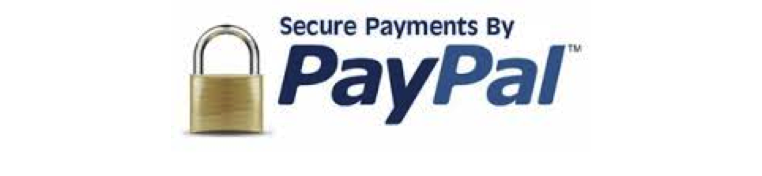
☐ Through wire transfer to our Kelele Africa account.
Caixa Bank - Street: Jesusa Lara 29 – City: Torrelodones – Zip Code: 28250 – Country: Spain
IBAN (electronic version): ES3221004022742200155885
IBAN (Paper version): IBAN ES32 2100 4022 7422 0015 5885
BIC (SWIFT CODE): CAIXESBBXXX

Please fill up the information requested and send to info@keleleafrica.org.

Date:

Signature of sponsor:

